How to play the game:

WASD or Arrow Keys – Move
G – Ghost Mode
T – Torch
E – Interact
Esc – Pause the game
Left-Mouse Button – Shoot
Number Keys – Select the weapons

To Win the Game:-
- Kill all Ghosts
- Find & collect three energy cells to kill the Enemy Bosses
- Find Master Key & the end door to win

The GitHub repository can be found here:
https://github.com/SaiCharan123456/CMP112_U2_BoppanaS

Statement on Assets sourced externally:
All assets, aside from the scripts, were sourced externally.

Statement on AI usage:
Used AI to brainstorm game ideas, debug issues on GitHub, and grasp key concepts. Did not use any code generation tools to write the scripts.

A section that highlights how your submission meets each of the criteria listed above
- I used Git for version control, creating separate branches for each major feature and then merging them into the main branch. In these four main branches, I committed regularly as each feature was completed.
- 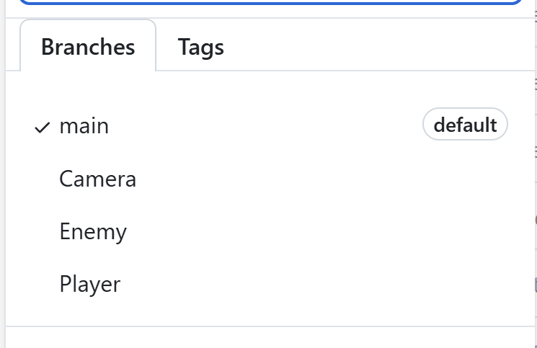

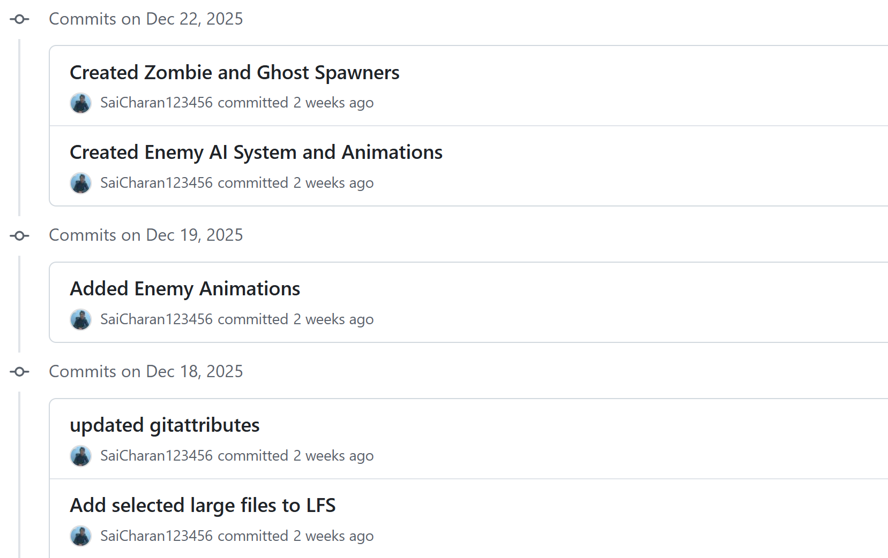

- I have so many scripts that implemented behaviour like player controller , enemy, weapon and etc.
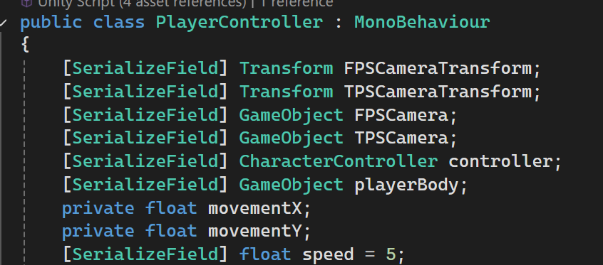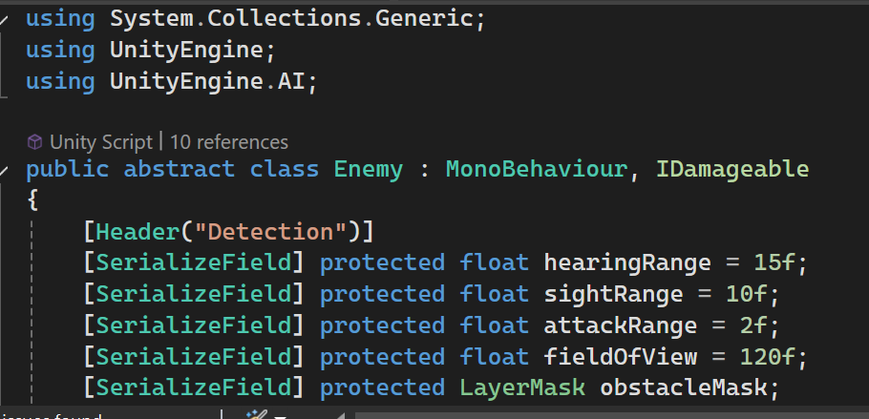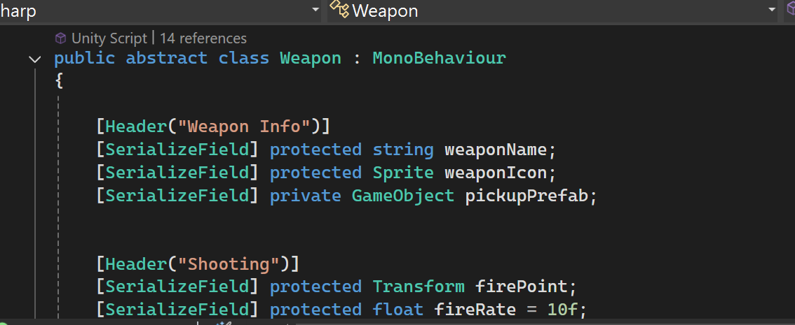

- I have used new Unity Input System in my game.
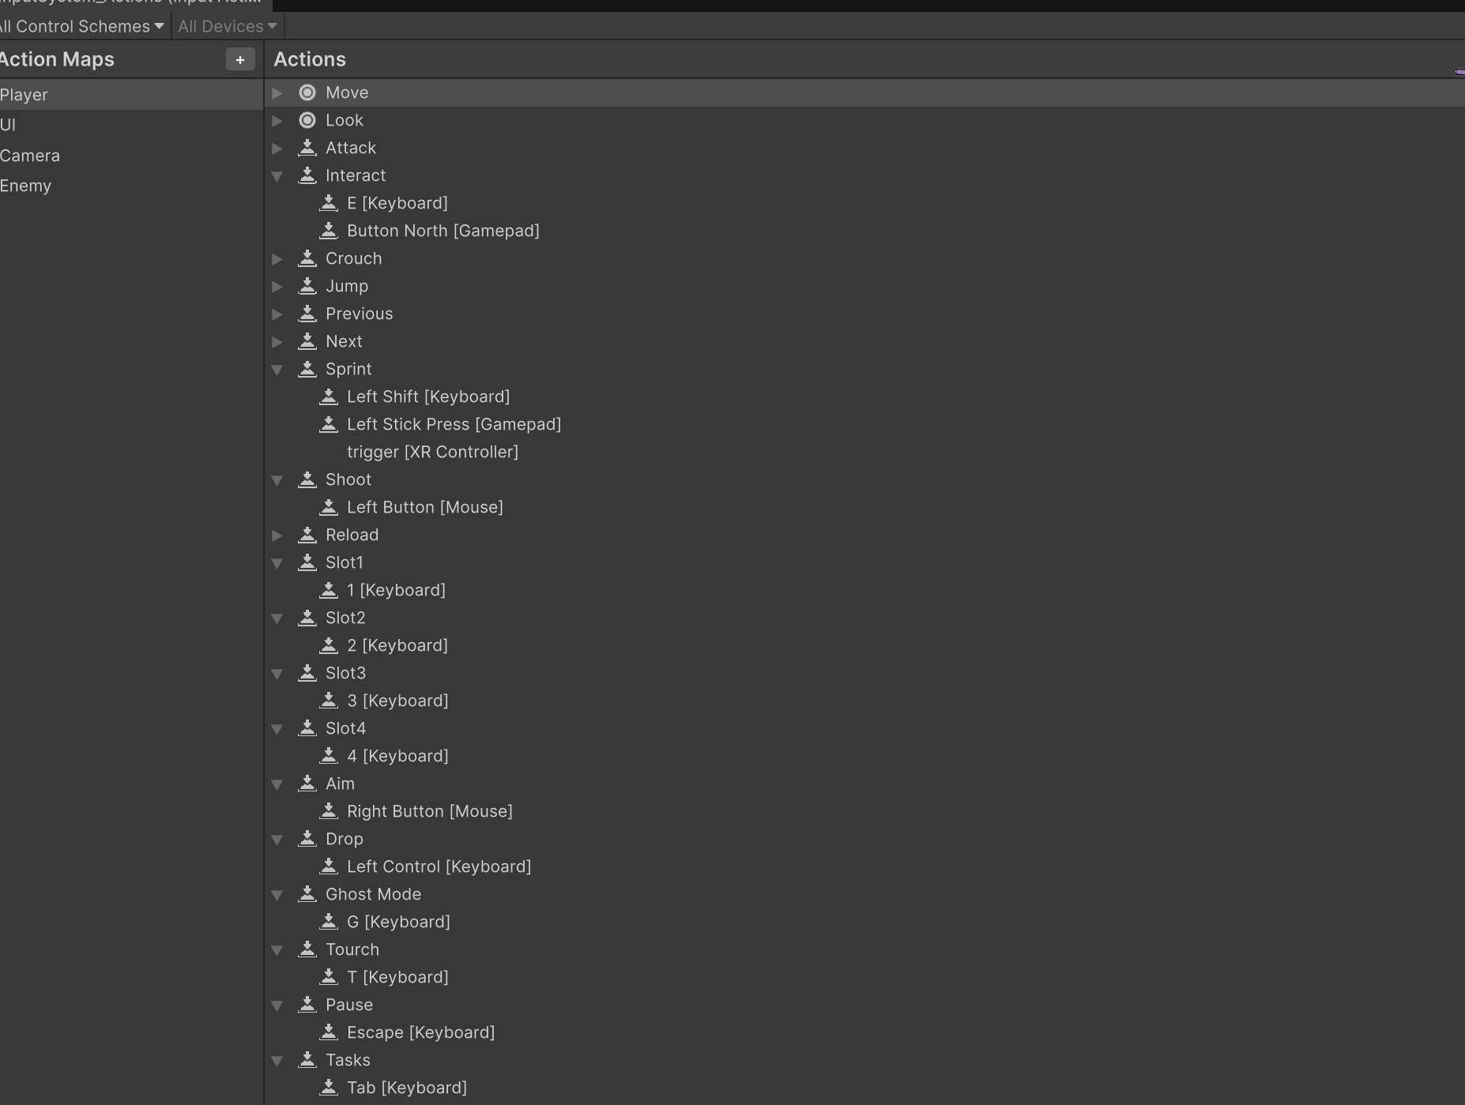

- Player has control of player game object which has player controller, player can control it using WASD keys.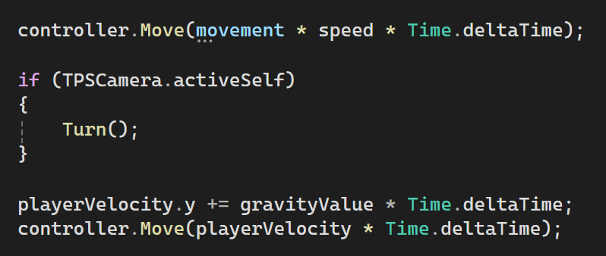
- Player and enemies, weapons, pickups can interact with each other.
- Grenades, weapons, enemies and etc uses Unity’s Rigidbody component to apply physics forces.
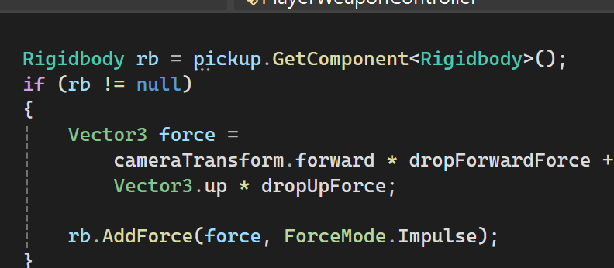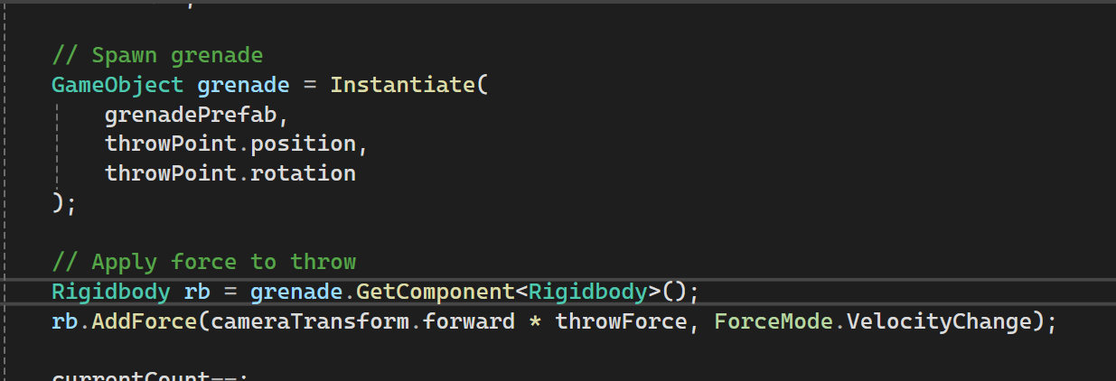

- I have background music in my game 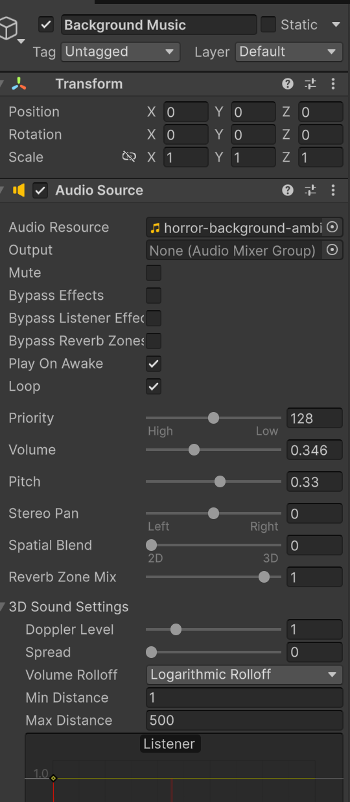
- I have various sound effects in my game like player footsteps, enemy attacks, getting hit, death, weapon shootings, etc.
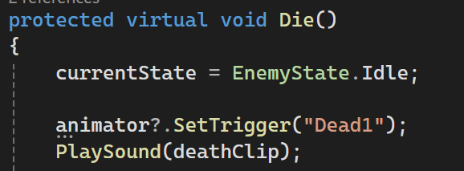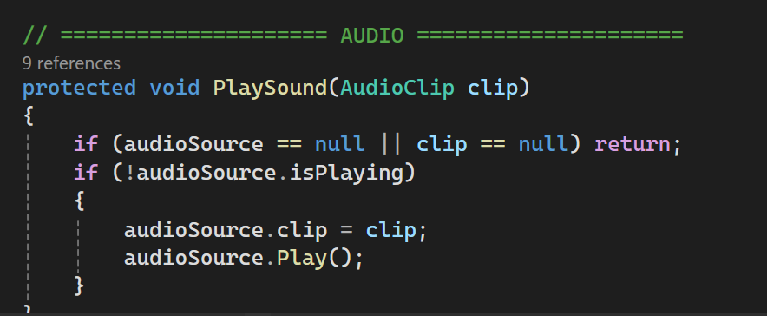

- I used inspector to expose variables
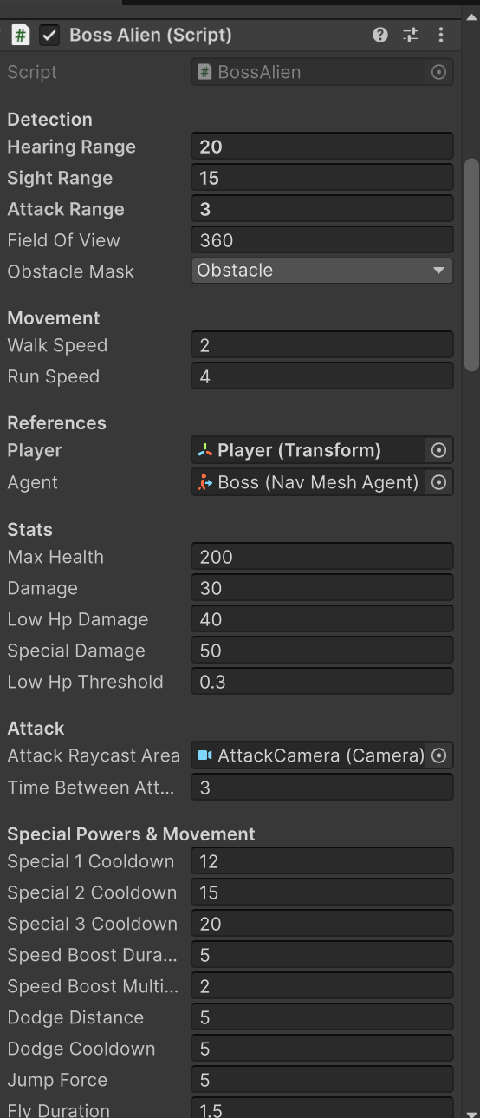

- I have used a random element in my spawners
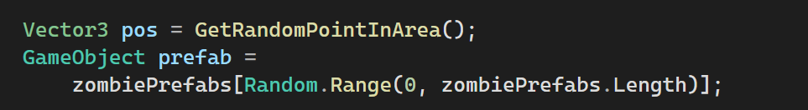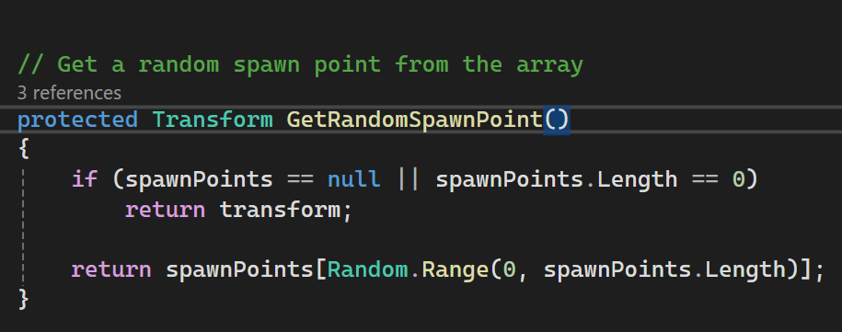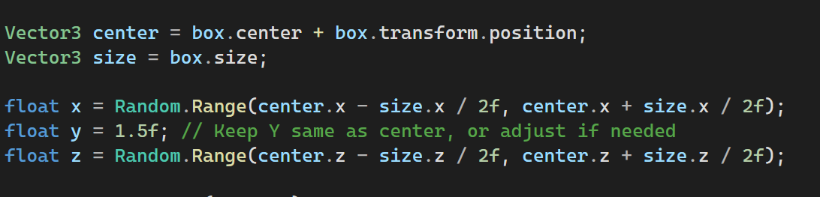

- The game is built to an executable file.

A discussion of the three most interesting parts of your time developing the game
(approx. 1-2 pages).

One of the most challenging yet interesting parts of my game development was building the Weapon System. I wanted to create a realistic first-person shooter (FPS) where the player could pick up, equip, unequip, and drop weapons. I started by watching several tutorials and YouTube videos, but most FPS tutorials I found either focused on a single weapon or simple weapon switching through buttons or mouse scroll, without the functionality to pick up or drop weapons.
Despite this, I didn't give up. After researching more online, I found different scripts, but none of them met my requirements. I reached out to friends who were also working on FPS games, but they were going for the simpler approach, with the weapon already attached to the player’s hand, meaning no picking up or dropping functionality.
At this point, I turned to ChatGPT. It helped me break down the logic into smaller pieces, rather than just giving me code. The key concept was:
- 🔫 Weapon GameObjects already in player hands (disabled)
- 📦 Pickup prefabs in the world (each with its own mesh)
- When picked up → weapon in hands is unlocked
- When dropped → pickup prefab is spawned again
So:
Pickup prefab = visual representation of a weapon
Weapon in hands = functional weapon
They are linked by reference, not by being the same object.
Armed with this concept, I combined what I had learned from the tutorials and coded the system myself. It was the hardest script I had written, but I was proud of how close I got to a real FPS weapon system, even if it was a simplified version.
The most unexpected part came after I had spent an entire week working on it. I realized I had been working in the wrong Git branch, and when I tried to switch, Unity crashed. I lost all my work because Unity hadn’t saved everything to the new branch. I later discovered that storing my project on a pen drive caused issues with Unity and Git, as the pen drive slowed things down and caused file access errors.
I had to redo everything from scratch. Fortunately, I had backed up some code, so I spent the next two days non-stop finishing the system. However, I ran into another issue with Git, where GitHub Desktop wasn’t letting me commit, and Git Bash wasn’t working. Eventually, I copied the project to my laptop, and everything worked much faster.
Lessons learned:
- Avoid working on Unity projects from a pen drive – keep it on your local machine.
- Don’t try switching branches or making changes in Unity at the same time to avoid conflicts.
Even with all the setbacks, I’m proud of how it all came together!
Moving on to another part of my game, I initially created separate scripts for both the third-person and first-person cameras. However, since both scripts had a lot of the same code with only minor differences, I started thinking about a better approach.
Instead of duplicating the code, I decided to create a base class for the camera controller. Both the first-person and third-person cameras could then inherit from this base class. This allowed me to reuse most of the logic while only needing to customize the specific parts for each camera type.
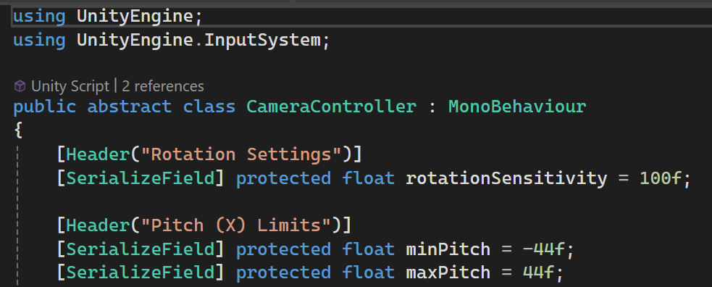
By doing this, I reduced redundancy and made the code much easier to manage.
Another issue I encountered was a small but tricky bug related to player rotation. I wanted the player to turn based on key input, so I created a Turn() function that seemed to be set up correctly. However, when I tested the game, the player wasn’t rotating as expected.
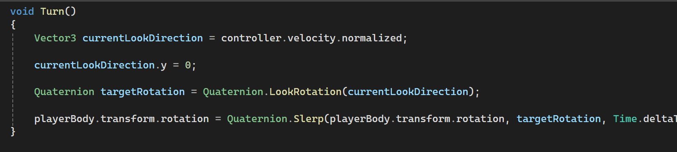
After hours of debugging, I discovered the issue: the order of function calls was wrong. The Turn() function was being called before the player’s movement function, which meant the rotation logic didn’t have the proper input values for which key the player had pressed.
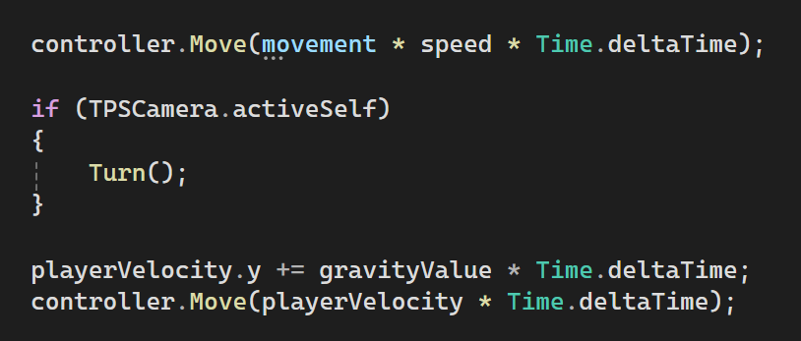
Once I realized that, I fixed the order by making sure that the player’s input was processed first, and then the rotation function was called afterward. That resolved the issue, and the player began turning in the correct direction when input was detected.
One of the most challenging parts of my project after the Weapon System was creating the Enemy AI System, especially since I have 6 to 7 different types of enemies in the game. Initially, I thought about writing separate code for each enemy type, but that felt inefficient—essentially just copying and pasting with small tweaks. So, I decided to use the inheritance method, similar to how I approached the weapon system earlier.
The next challenge was deciding the structure of inheritance—what should inherit from what. After doing some research, I came up with a flowchart for the system. I would have a single Enemy Base Class, and then create child classes for each enemy type, such as Ghosts, Zombies, Monsters, and Boss enemies. Since I had different types of Ghosts and Zombies, I made additional child classes for those as well.
Once the structure was set, I created the Enemy Base Class, which covered the basic movement and shared behaviors common to all enemies. However, I made sure it didn’t contain anything specific to a particular enemy type.
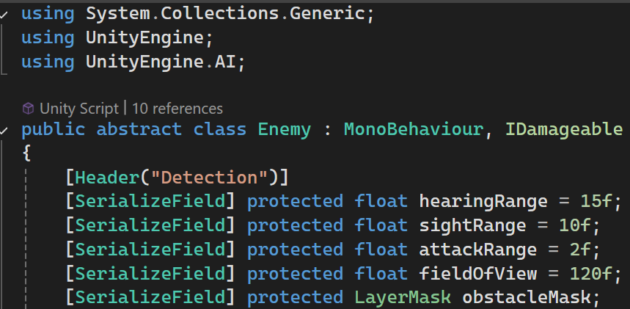
During this process, I stumbled upon two new concepts that significantly helped with the development: State Machines (or Finite State Machines) and Interfaces. When researching enemy AI systems, I came across these terms and decided to dive deeper into them.
- State Machines helped organize the different states that an enemy could be in (e.g., idle, patrolling, attacking, chasing). Using state machines made it easier to manage transitions between these states, simplifying the overall structure of the enemy behaviors.
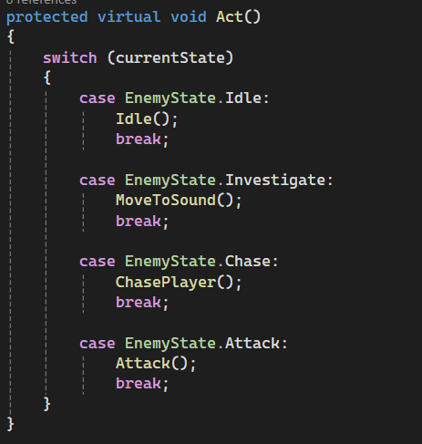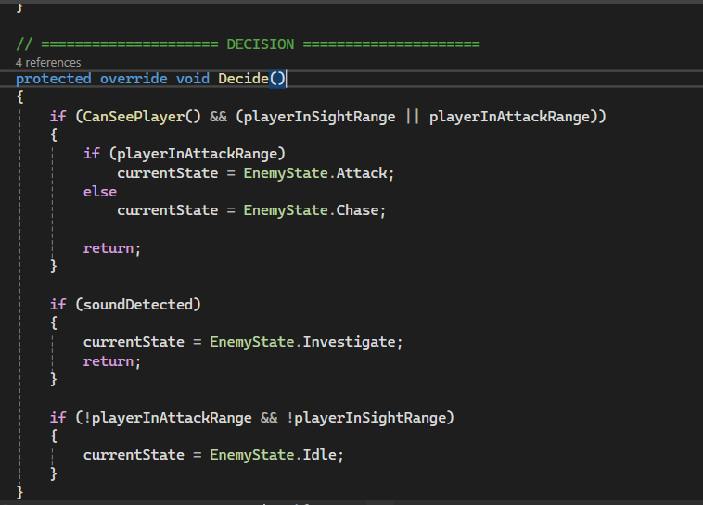
- Interfaces, on the other hand, were crucial for avoiding code duplication. Instead of writing separate damage-handling code for each enemy type, I used interfaces to allow all enemies to share a common method for taking damage, without needing to repeat the same logic.
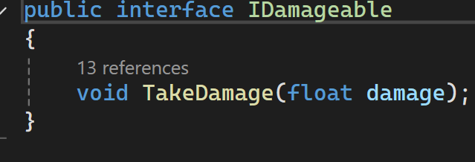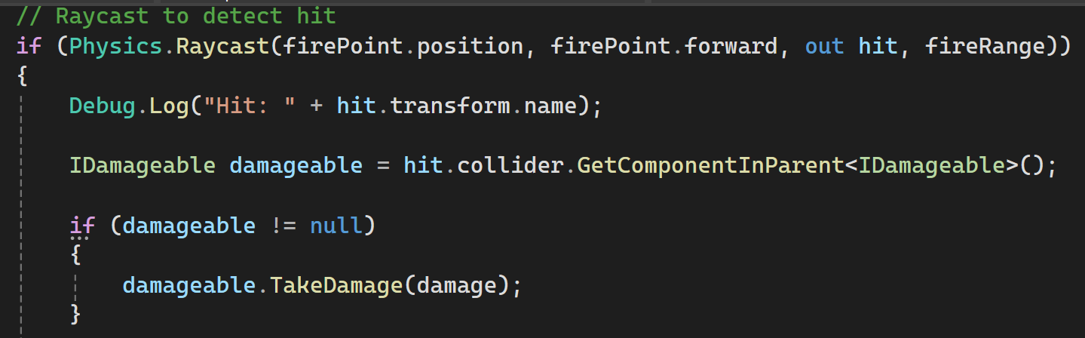
Thanks to these two concepts, I was able to build a much cleaner and more flexible enemy AI system.

A critical evaluation of the project and your own work. You will discuss the successes of
the work and where it can be improved. You will also discuss your own performance and
lessons learned for any future work. (approx. 0.5-1 page).

Two things that I’m particularly proud of in this project are the Weapon System and the Enemy AI System. Both of these turned out exactly as I wanted them, with only some minor bugs, but they’re insignificant enough that they don’t affect the overall gameplay. Most of the project is exactly as I wanted, but the Weapon Spawner and Ammo Spawner could still use some improvement. While both systems work fine, I encountered a issue where the Unity editor sometimes gets stuck when I enter Play mode. To resolve this, I had to restart the editor 2-3 times, and despite my attempts to fix it, I couldn't identify the error. If I had fixed that, the project would have been perfect. Throughout the project, I made extensive use of inheritance, which helped me avoid duplicating code, and I also implemented the Singleton pattern, which helped manage certain game features more efficiently. One of the most valuable lessons I’ve learned in game development is that while defeating a boss is hard, creating one is equally difficult. When it comes to GitHub, I encountered numerous challenges. In my previous project, I struggled with GitHub, so this time I made sure to learn about merging, branching, and other GitHub concepts from the start. Although I was able to create branches and merge them correctly this time, new issues popped up. I ran into problems with committing, switching branches, and using Git LFS (Large File Storage). The issue with LFS arose because some of my player textures were over 100 MB, and when I initiated LFS, it tracked all the project files, which caused it to fill up. As a result, I couldn’t push my repository online. After some trial and error, I realized that I needed to untrack everything except the texture files, but it still didn’t work. Eventually, I had to remove LFS completely, leaving everything except the textures in regular Git, which allowed me to push the project online successfully. This experience taught me two important lessons: 1) Don’t switch branches or make changes in Unity at the same time to avoid conflicts, and 2) Always keep your project on your local machine rather than a pen drive, as it can slow things down and make the project more vulnerable to errors or viruses. Reflecting on this project, I realize that while I didn’t make the same mistakes as in my previous project, I still made new ones. However, I believe I’ll avoid repeating these in future projects. It really feels like learning by doing, and each mistake is a step towards improving my skills for the next one.

